**Problem Description**

The goal is to determine the **shortest path** from a starting location Azimpur (**Home**) to the target destination Farmgate (**UAP**) within a directed, weighted graph that models a segment of Dhaka city’s road network. The problem requires applying the **A\*** search algorithm to efficiently identify the path with the minimum travel cost.

**Graph Representation**

* **Nodes (Vertices):** Each node corresponds to a specific real-world location.
* **Edges:** A directed edge (u → v) indicates a valid travel direction along a road between two locations.
* **Edge Weights:** Every edge carries a cost (measured in kilometers), representing the actual travel distance.
* **Heuristic Values:** Each node has an associated heuristic value *h(n)*, which estimates the remaining cost from that node to the goal (UAP). These heuristics are calculated as straight-line (Euclidean) distances.

**Objective**

The objective is to apply the **A\*** search algorithm to compute the **optimal path** from Home to UAP by minimizing the total cost of travel.

**Constraints**

1. The graph is **directed**, meaning movement is only allowed in the specified direction of edges.
2. All edge costs are **non-negative**, ensuring the suitability of Dijkstra’s and A*.
3. Heuristic values must satisfy:
   * **Admissibility:** They never overestimate the true cost to the goal.
   * **Consistency:** They respect the triangle inequality across all edges.

**Approach**

1. **Implement the A* algorithm**:
   * Use the evaluation function:

**f(n)** = g(n) + h(n)

where *g(n)* is the actual cost from the start node and *h(n)* is the heuristic estimate to the goal.

* + Maintain two sets: **Open (frontier)** and **Closed (expanded nodes)**.
  + Expand the node with the **lowest f(n)** at each step.

1. **Outputs generated:**
   * The optimal path and its total travel cost.
   * A **search tree** showing the explored states.
   * An **iteration table** recording each expansion step (path, g(n), h(n), f(n), Open, Closed).
   * A heuristic **consistency check** table across all edges.

**Expected Outcome**

* Identification of the **optimal route** from Home to UAP with the minimum cost.
* Confirmation that the heuristic used is both **admissible** and **consistent**, guaranteeing that A* finds the optimal path.
* A full trace of the search process, including **iteration logs** and **visualized search trees**.

**MAP**

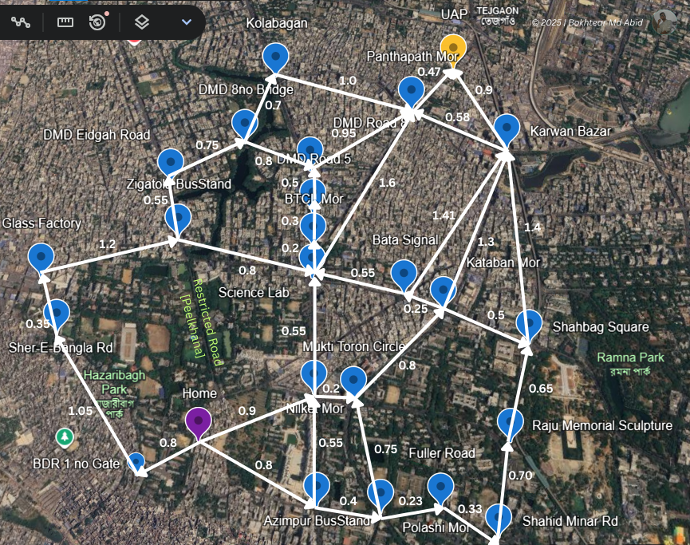

**Figure:** Map with Path Cost (u → v)

**Heuristic values:**

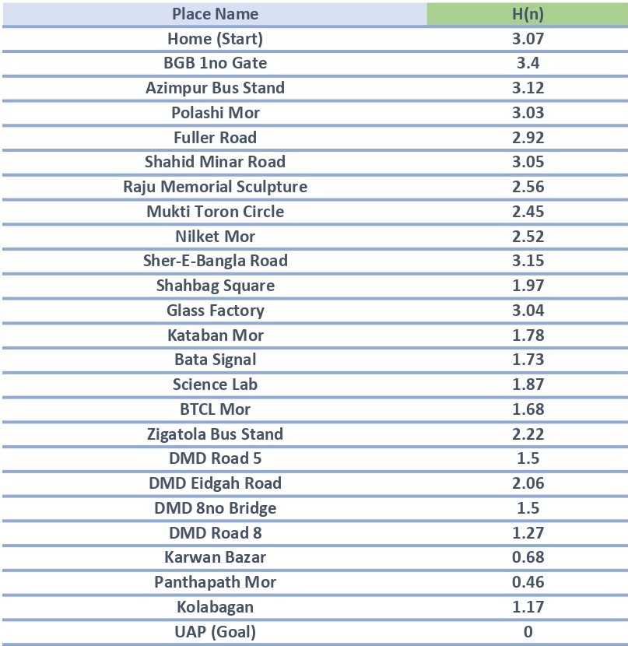

**Path cost table:**

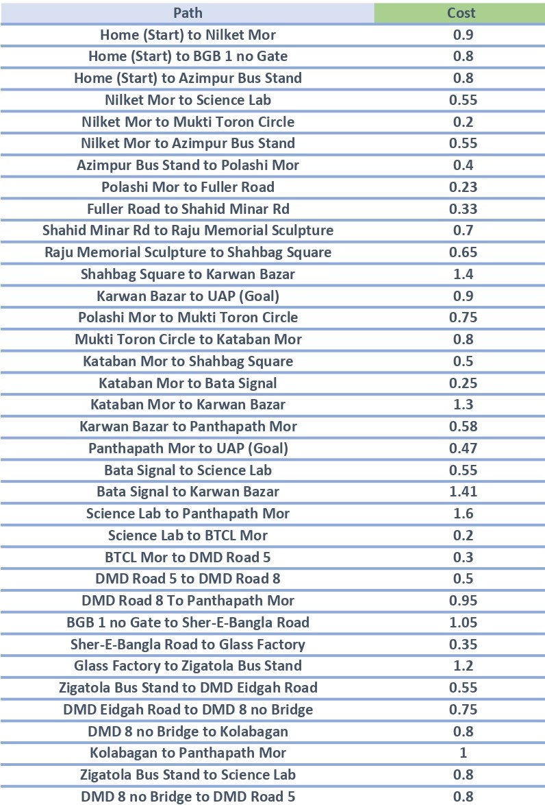

**Search tree:**

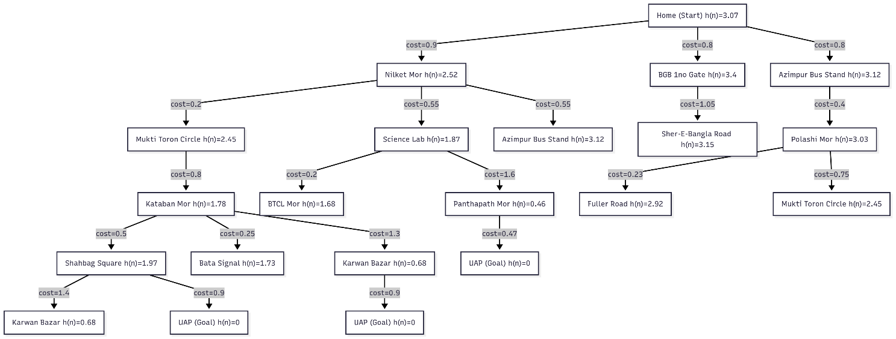

**Figure:** Search Tree with Path Cost and Heuristic Value

**A* Search Iteration Table:**

| **Iteration** | **Paths** | **g(n)** | **h(n)** | **f(n)** | **Open List (sorted by f(n))** | **Closed List** |
| --- | --- | --- | --- | --- | --- | --- |
| 1 | Home | 0.00 | 3.07 | 3.07 | Home |  |
| 2 | Home -> Nilket Mor | 0.90 | 2.52 | 3.42 | Nilket Mor, BGB 1no Gate, Azimpur Bus Stand | Home |
| 3 | Home -> Azimpur Bus Stand | 0.80 | 3.12 | 3.92 | Azimpur Bus Stand, Nilket Mor, BGB 1no Gate | Home |
| 4 | Home -> BGB 1no Gate | 0.80 | 3.40 | 4.20 | BGB 1no Gate, Azimpur Bus Stand, Nilket Mor | Home |
| 5 | Home -> Nilket Mor -> Science Lab | 1.45 | 1.87 | 3.32 | Science Lab, Azimpur Bus Stand, BGB 1no Gate, Mukti Toron Circle | Home, Nilket Mor |
| 6 | Home -> Nilket Mor -> Mukti Toron Circle | 1.10 | 2.45 | 3.55 | Mukti Toron Circle, Science Lab, Azimpur Bus Stand, BGB 1no Gate | Home, Nilket Mor |
| 7 | Home -> Nilket Mor -> Science Lab -> BTCL Mor | 1.65 | 1.68 | 3.33 | BTCL Mor, Mukti Toron Circle, Science Lab, Azimpur Bus Stand, BGB 1no Gate | Home, Nilket Mor, Science Lab |
| 8 | Home -> Nilket Mor -> Science Lab -> Panthapath Mor | 3.05 | 0.46 | 3.51 | Panthapath Mor, BTCL Mor, Mukti Toron Circle, Azimpur Bus Stand, BGB 1no Gate | Home, Nilket Mor, Science Lab |
| 9 | Home -> Nilket Mor -> Science Lab -> Panthapath Mor -> UAP | 3.52 | 0.00 | 3.52 | UAP, BTCL Mor, Mukti Toron Circle, Azimpur Bus Stand, BGB 1no Gate | Home, Nilket Mor, Science Lab, Panthapath Mor |
| 10 | Goal reached (UAP) |  |  |  |  |  |

**Admissibility:**

A heuristic is admissible if it never overestimates the true cost to reach the goal from any node. Formally,

**h(n)≤h∗(n)**

where h(n) is the heuristic value, and h∗(n) is the actual optimal cost from node n to the goal. This ensures that A* always finds an optimal path, because the heuristic is optimistic (it either underestimates or equals the true cost, but never exaggerates).

**Admissibility Table:**

| **node** | **h(n)** | **h∗(n)** | **slack (true-h)** | **admissible?** |
| --- | --- | --- | --- | --- |
| UAP (Goal) | 0.00 | 0.00 | 0.00 | TRUE |
| Panthapath Mor | 0.46 | 0.47 | 0.01 | TRUE |
| Karwan Bazar | 0.68 | 0.90 | 0.22 | TRUE |
| DMD Road 8 | 1.27 | 1.42 | 0.15 | TRUE |
| Science Lab | 1.87 | 2.07 | 0.20 | TRUE |
| Shahbag Square | 1.97 | 2.30 | 0.33 | TRUE |
| Nilket Mor | 2.52 | 2.62 | 0.10 | TRUE |
| Azimpur Bus Stand | 3.12 | 3.17 | 0.05 | TRUE |
| Home (Start) | 3.07 | 3.52 | 0.45 | TRUE |

**Explanation:**

* For each node, h(n)≤h∗(n)*,* so the heuristic is admissible.
* The slack is always non-negative, meaning the heuristic never overestimates.
* This ensures that A* will find the optimal path (cost 3.52).

**Consistency**

A heuristic is consistent (or monotonic) if for every edge u→v with cost c(u,v), the following holds:

**h(u)-h(v)≤c(u,v)**

This means the estimated cost from u is never greater than the step cost to v plus the estimate from v. Consistency guarantees that the f(n)=g(n)+h(n) values along a path are non-decreasing, ensuring efficient A* search without re-expanding nodes

| **edge u to v** | **h(u)** | **h(v)** | **h(u)-h(v)** | **path cost c(u,v)** | **slack (c(u,v) - [h(u)-h(v)])** | **consistent?** |
| --- | --- | --- | --- | --- | --- | --- |
| Home to Nilket Mor | 3.07 | 2.52 | 0.55 | 0.9 | 0.35 | Yes |
| Nilket Mor to Science Lab | 2.52 | 1.87 | 0.65 | 0.55 | -0.10 | No |
| Science Lab to Panthapath Mor | 1.87 | 0.46 | 1.41 | 1.6 | 0.19 | Yes |
| Panthapath Mor to UAP | 0.46 | 0.00 | 0.46 | 0.47 | 0.01 | Yes |
| Home to Azimpur Bus Stand | 3.07 | 3.12 | -0.05 | 0.8 | 0.85 | Yes |
| Azimpur Bus Stand to Polashi Mor | 3.12 | 3.03 | 0.09 | 0.4 | 0.31 | Yes |
| Polashi Mor to Fuller Road | 3.03 | 2.92 | 0.11 | 0.23 | 0.12 | Yes |
| Fuller Road to Shahid Minar Rd | 2.92 | 3.05 | -0.13 | 0.33 | 0.46 | Yes |
| Shahid Minar Rd to Raju Memorial Sculpture | 3.05 | 2.56 | 0.49 | 0.7 | 0.21 | Yes |
| Raju Memorial Sculpture to Shahbag Square | 2.56 | 1.97 | 0.59 | 0.65 | 0.06 | Yes |
| Shahbag Square to Karwan Bazar | 1.97 | 0.68 | 1.29 | 1.4 | 0.11 | Yes |
| Karwan Bazar to UAP | 0.68 | 0.00 | 0.68 | 0.9 | 0.22 | Yes |
| Nilket Mor to Mukti Toron Circle | 2.52 | 2.45 | 0.07 | 0.2 | 0.13 | Yes |
| Mukti Toron Circle to Kataban Mor | 2.45 | 1.78 | 0.67 | 0.8 | 0.13 | Yes |
| Kataban Mor to Karwan Bazar | 1.78 | 0.68 | 1.10 | 1.3 | 0.20 | Yes |
| Science Lab to BTCL Mor | 1.87 | 1.68 | 0.19 | 0.2 | 0.01 | Yes |
| BTCL Mor to DMD Road 5 | 1.68 | 1.50 | 0.18 | 0.3 | 0.12 | Yes |
| DMD Road 5 to DMD Road 8 | 1.50 | 1.27 | 0.23 | 0.5 | 0.27 | Yes |
| DMD Road 8 to Panthapath Mor | 1.27 | 0.46 | 0.81 | 0.95 | 0.14 | Yes |

**Explanation:**

* For the edge "Nilket Mor to Science Lab", we have h(u)−h(v)=0.65*h*(*u*)−*h*(*v*)=0.65 but the path cost is only 0.55. This violates consistency because 0.65>0.550.65>0.55. Therefore, the heuristic is not consistent for this edge.
* For all other edges, h(u)−h(v)≤c(u,v) holds, so they are consistent.
* Since there is at least one inconsistency (Nilket Mor to Science Lab), the overall heuristic is not consistent.

**Code (Using Python):**

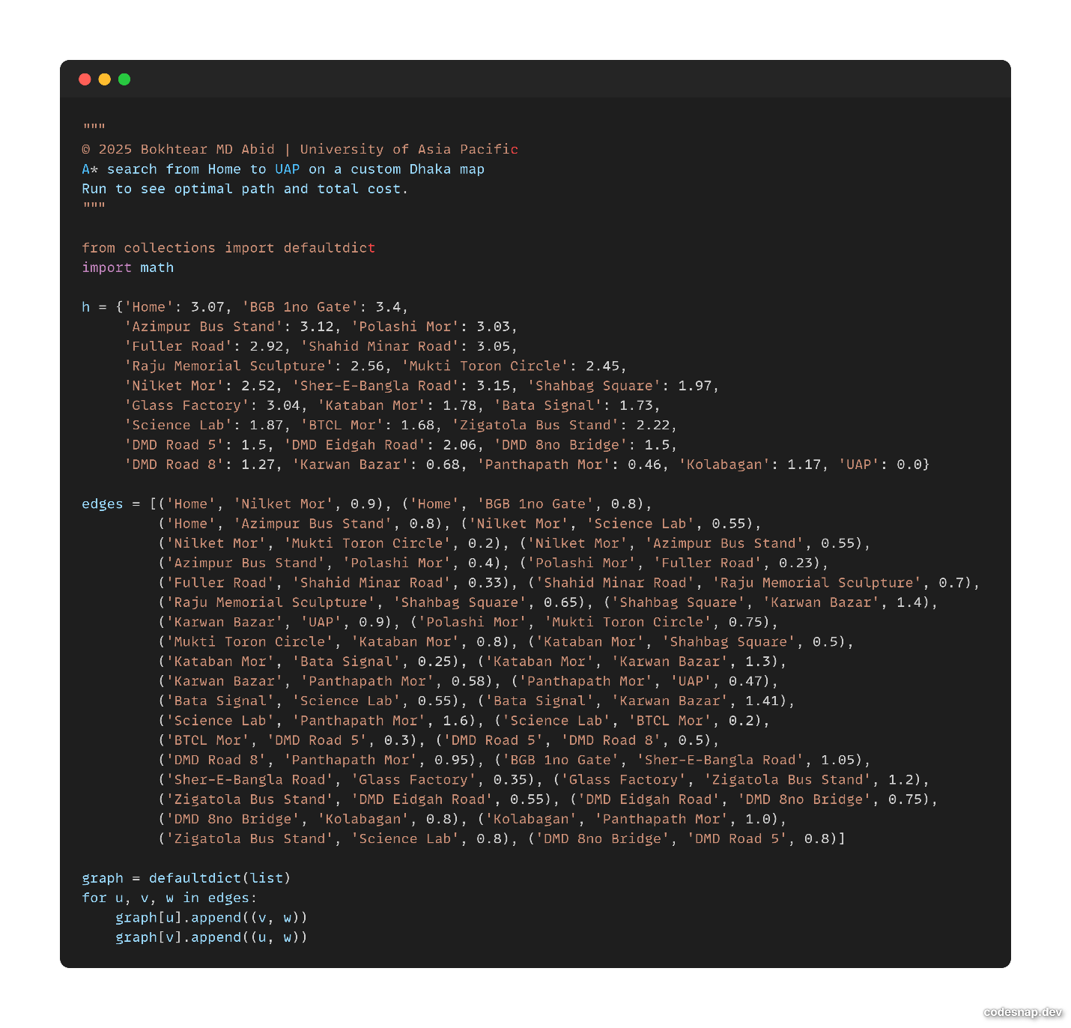

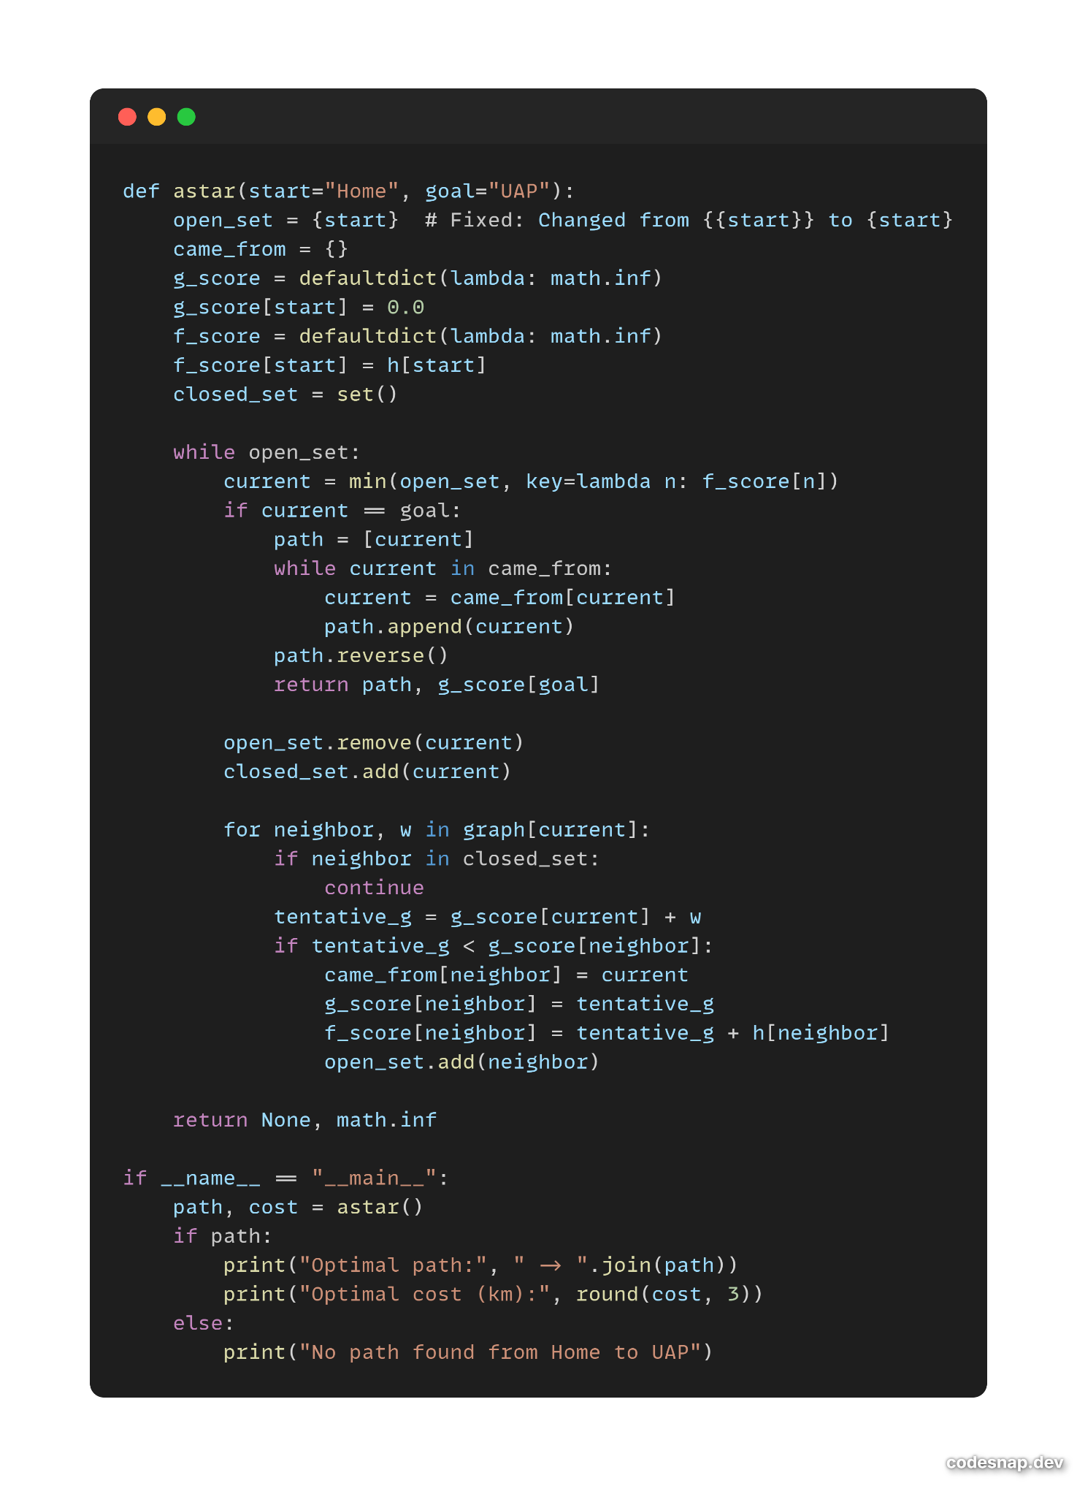

**Conclusion:**

In this problem, we modeled the journey from **Home (Start)** to **UAP (Goal)** as a directed, weighted graph and applied the A* search algorithm to find the optimal route. The algorithm successfully identified the shortest path with a total cost of **3.52**, balancing the actual cost g(n)*g*(*n*) with the heuristic estimate h(n)*h*(*n*).

Our analysis revealed that the heuristic values used were **admissible** (never overestimating the true remaining cost to the goal), ensuring that A* found the optimal path. However, the heuristic was **not fully consistent**, as the edge from **Nilket Mor to Science Lab** violated the consistency condition (h(u)−h(v)>c(u,v)). Despite this inconsistency, which may cause occasional re-expansions and reduce efficiency, the admissibility property guaranteed optimality.

The results were presented in multiple forms:

* A **search tree** illustrating all explored paths,
* A **stepwise iteration table** tracing the evolution of the OPEN and CLOSED sets,
* And a **consistency table** validating the heuristic across key edges.

Thus, the study demonstrates how A* search, combined with an admissible heuristic, provides an effective and optimal solution for real-world navigation problems, even in cases where the heuristic is not perfectly consistent. The optimal path identified was:

**Home → Nilket Mor → Science Lab → Panthapath Mor → UAP** (cost 3.52).